1、建表

Name varchar(20) not null,

Sex varchar(4),

Birth YEAR,

Department varchar(20) not null,

Address varchar(50)

)

create table Score(

Id int(10) primary key AUTO_INCREMENT,

Stu_id int(10) not null,

C_name varchar(20) ,

Grade int(10)

)

2、为student插入数据

insert into Student()

values(901,'张老大','男',1985,'计算机系','北京市海淀区')

,(902,'张老二','男',1986,'中文系','北京市昌平区')

,(903,'张三','女',1990,'中文系','湖南省永州市')

,(904,'李四','男',1990,'英语系','辽宁省阜新市')

,(905,'王五','女',1991,'英语系','福建省厦门市')

,(906,'王六','男',1988,'计算机系','湖南省衡阳市');

3、为score插入数据

insert into Score(Stu_id,C_name,Grade)

value(901,'计算机',98)

,(901,'英语',80)

,(902,'计算机',65)

,(902,'中文',88)

,(903,'中文',95)

,(904,'计算机',70)

,(904,'英语',92)

,(905,'英语',94)

,(906,'计算机',90)

,(906,'英语',85)

//修改

update Score set Grade = 68 where Stu_id = 906 and C_name = "英语";

//删除

delete from Score where C_name = "计算机" and Grade = 65;

//查询

select * from student where Department in ("计算机系","英语系");

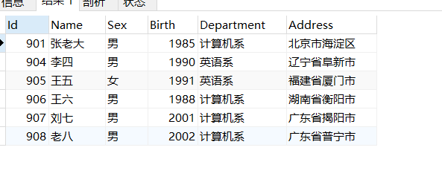

select Id,Name,Sex,Year(Now())-Birth as "age",Department,Address from student where Year(Now())-Birth between '18' and '22';